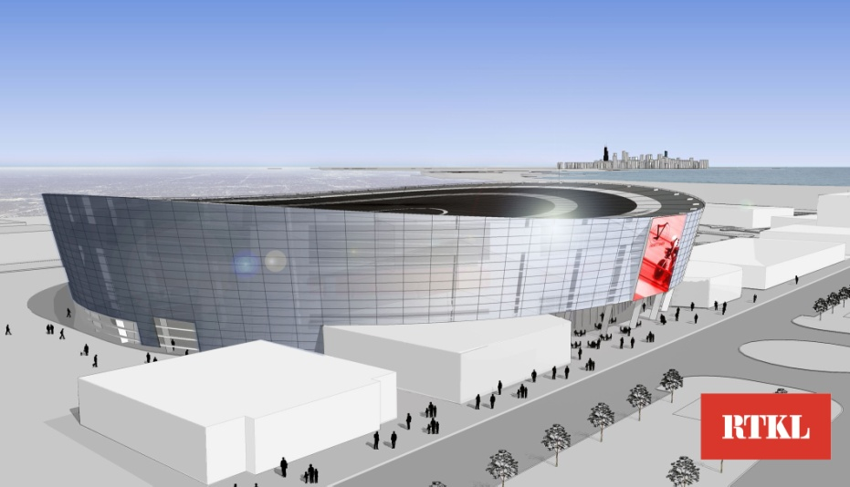
Name: Chicago Velo Campus Indoor Velodrome
Location: Chicago, Il
Architect: RTKL Associates
Client: Chicago Velo Campus L3C
Date Completed: 2013
Cost: $45 Million estimate
Seating:
Track Length: 250m
Facilities include: Art Indoor 250m Velodrome Track, Outdoor and Indoor Mountain Bike tracks (MTB), Outdoor Cyclocross Track, Triathlon Training Center,
Wind Tunnel Facility, Indoor Olympic Sized Swimming Pool
Indoor 400 meter Running Track, Fitness Center, Coaching and Education Facility
Olympic Development Training Center, Youth Beginner, Elite and Masters Programs, Community Center, Physical Therapy and Sports Medicine Center, Sports Retail, Cycling Museum
Restaurant, Cafe, and a Healthy Juice Bar

Why is it good: This project is good in that is creates a community hub. It is the focus of this 500 acre site to include everything listed above as well as 13,000 homes on the south side of Chicago along the lakefront between 79th and 91st Streets.
What you plan to learn from it: This design combines a mixed use facility with a cycling track. This solves 2 of my main problems when talking about sustainability. First it allows more people to occupy the space thus eliminating dead spots in time when the building is heating/cooling the space and no one is in there. And secondly it helps emphasize my intent as creating a hub not only for cycling but for people as well. This gets more people to the site which would not be there if it was just a cycling facility.

Land Area: The center piece of a much larger 500 acre site
Land Features: Urban

- First Floor Plan(Gross 114,237 sq ft)
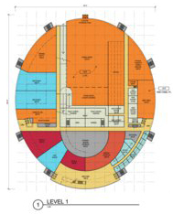
- Circulation (cream) 17,320 sq ft
- Office (light cyan) 3,628 sq ft
- Service (dark gray) 9,546 sq ft
- Leaseable Space (orange) 49,595 sq ft
- Retail (red) 6,574
- Restaurant (dark cyan) 12,455 sq ft
- Track support (light gray) 15,155 sq ft

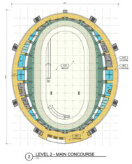
- Second Floor Plan(Gross 114,234 sq ft)
  - Circulation (cream) 22,666 sq ft
  - Office (light cyan) 1,314 sq ft
  - Service (dark gray) 5,462 sq ft
  - Seating (green) 12,910 sq ft
  - Restaurant (dark cyan) 3,731 sq ft
  - Track 17,801 sq ft
  - Infield 45,384

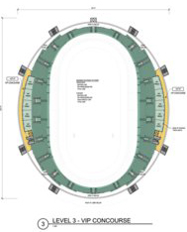
- Third Floor Plan(Gross 114,234 sq ft)
  - Circulation (cream) 4,558 sq ft
  - Service (dark gray) 2,480 sq ft
  - Seating (green) 30,918 sq ft
  - Box Seats- 4,630 sq ft

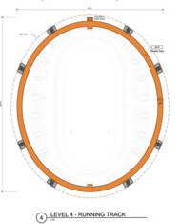
- Fourth Floor Plan(Gross 114,234 sq ft)
  - Service (dark gray) 2,480 sq ft
  - Running Track 15,013 sq ft

Total Assignable Area: 167,128 sq ft 59%
Fourth Floor: 15,013 sq ft
Third Floor: 4,633 sq ft
Second Floor: 68,230 sq ft
First Floor: 79,252 sq ft

Total Un-Assignable Area: 116,429 sq ft 41%
Fourth Floor: 2,480 sq ft
Third Floor: 37,956 sq ft
Second Floor: 41,038 sq ft
First Floor: 34,955 sq ft

(Note: Track and Infield only calculated in
ground floor sq ft and in all 3 levels in gross
area conditioned space)

Total Gross Area: 283,557sq ft
(456,936 sqft total conditioned space)

http://newcity.com/2011/02/22/wheel-dreams-can-emanuele-bianchi-win-his-race-to-build-the-45-million-chicago-velo-campus-by-2013/

